
Business / Technical Brief

Design Specification

Domino-INT002 – Supplier Integration from Fusion to WMS
23rd May 2024, Version 1a.
Copyright © 2024, Oracle and/or its affiliates
Confidential – Oracle Restricted

Document Control

Change History
Date | Author | Version | Description
22-May-2024 | Amit Sharma | 1a | Initial Version

Reviewed By
Date | reviewer | role

Table of contents
Document Control 2
Change History 2
Reviewed By 2
Introduction 4
Purpose 4
Overview and Scope 4
Business Objectives 5
Process Overview 5
Mapping 6
Pre-Conditions 6
Risk Matrix 6
Other Integrations Design Dependency 6
Frequency 7
Business Use Case: 7
Open Items 7
Technical Overview 8
Scope 8
Glossary 8
Document References 8
Sample Data & Mapping Template 8
Frequency 9
Assumptions 9
High Level Approach 9
Pre-Requisites 10
Integration Analysis – XxPublishSupplierErpToWms 10
Integration Components 11
Required Connections 11
Integration Outline 12
Main Code Flow Snippet 21
Global Fault 23
Migration Steps 25
Unit Testing 26
Open and Closed Issues 26

Introduction

Purpose
This Design Specification documents the detailed design for Supplier Interface from Fusion to Oracle Cloud WMS.
This document describes the functional design of the list of attributes which need to be interfaced from Fusion to Cloud WMS through Oracle Integrated Cloud Service (OIC) to create suppliers in WMS. The design document also covers the event attribute mappings from Fusion to Oracle Cloud WMS Functional Columns.

Overview and Scope
Overview
For creating PO receipts, supplier data is required in Cloud WMS System. Since suppliers would be created directly in Fusion and synchronization service will need to send the create/ update information to Cloud WMS.
Business Purpose
All Purchasing transactions will be recorded in Oracle Cloud ERP, however the warehouse activities will be carried out for all the manufacturing facilities (inventory organization enabled in WMS) using Cloud WMS. Both the systems need to communicate to complete the Receiving part of the Procure to Pay cycle for every single procurement transaction. Requisitions, Purchase orders will be primarily recorded in Oracle Procurement Cloud. Actual Receipts would be recorded in Cloud WMS upon receiving the Receipt Advice. However, to enable this receiving part of the procure to pay cycle, supplier data in Cloud WMS needs to be in sync with Fusion. WMS will be the material transaction system and Fusion will be the operational system (system of records). Hence, a specific interface needs to be built between Fusion and Cloud WMS as per the Business Requirement to keep Supplier data in sync between the two systems.
This design document focuses on building an interface between Fusion and Cloud WMS so that Supplier data can be kept in sync.
Scope
The scope of this document is limited to functional and technical design of the interface to communicate Supplier master data additions and updates from Fusion to Cloud WMS System.

Functional Overview

The Vendor/Supplier in WMS needs the following inputs to manage inbound orders. To process the incoming purchase orders, the WMS module should receive the following required inputs from Fusion Purchasing ERP:

- Company Code
- Vendor Name
- Address Line1 of Supplier Site
- Address Line2 of Supplier Site
- Address Line3 of Supplier Site
- City of Supplier Site
- State of Supplier State
- Zip Code of supplier Site
- Country of Supplier Site
- Phone Number of Supplier Site
- Email address of Supplier site
- Contact of Supplier Site

By integrating Oracle Fusion Purchasing ERP to WMS, all the vendors and associated details, as listed above, is expected to flow seamlessly into WMS, which will help in processing the inbound purchase orders accurately.
Suppliers are created and approved in Fusion, as soon they are approved, suppliers are interfaced to WMS by a scheduled process in OIC.
Allows for below transactions:
- Create
- Update (any change made to the mapping column in Fusion is updated in WMS)

Business Objectives

The following objectives were captured during the Focus Stage and are addressed by the functional designs described in this document:

Integration ID | Category | Short description
INT002 | Fusion Purchasing ERP to Vendor master in WMS | Creation of Vendor details in Warehouse management system cloud.

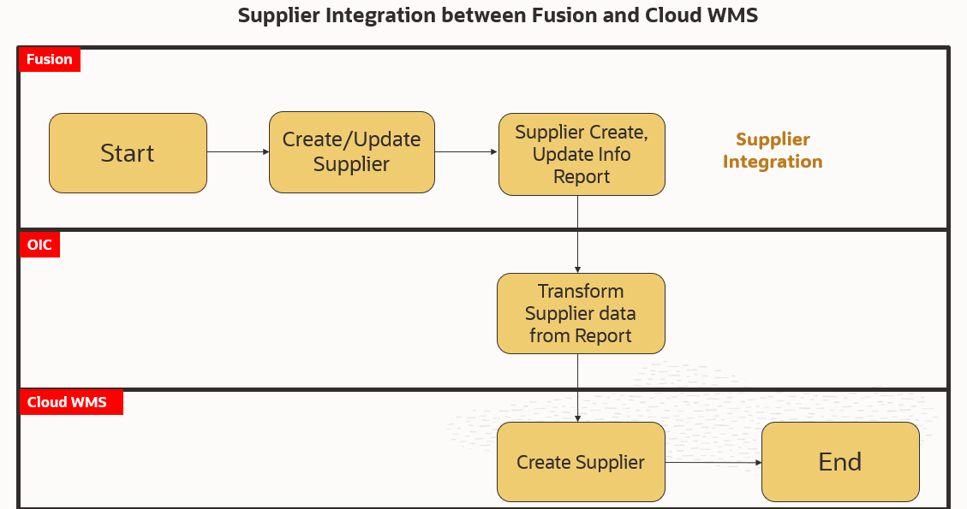

Mapping

Pre-Conditions
- Oracle Fusion Purchasing ERP and destination systems (WMS) should already contain synchronised and aligned vendor masters as a part of the Vendor Master Data migration.
- New Vendor, Change Vendor and Inactive Vendors are taken care of during integration.
- Business Units against which vendors are created should exist in WMS.

Risk Matrix
Risk | Impact  (1 to 5) | Probability  (1 to 5) | Mitigation
PO Interface Failure to WMS due to missing item in WMS | 5 | 2 | Valid error message stating the integration failure. Re-run the item integration first and then the PO receipt advice integration
PO interfaced to WMS with supplier details missing | 2 | 2 | Re-run the supplier integration first and then the PO receipt advice integration

Other Integrations Design Dependency

Name | Dependency | comments
 |  | No dependency since it is a master data integration

Frequency
Responsiveness | Frequency | Comments
Xx_INT002_SUPPLIERS_EXTRACT_ESS_JOB | Scheduled in OIC: Every 1 Hour

Business Use Case:
- New Vendor/Supplier Creation in Fusion and interface to WMS
- Vendor update in Fusion and interface to WMS

Open Items
This section is used to summarize any open items related to the design.
No. | open item | data required/Owner | status | impact if not closed
001 | What is the supplier data volume for DLG (during cutover and business as usual)? | Domino
002 | How to handle multiple sites and assignment to Client BUs | OC/Domino
003

Technical Overview

Scope
The objective of this section is to provide Domino Printing with a Technical Specification for Outbound Integration to publish Suppliers from Fusion to WMS.

Glossary
Annotation | Definition
ERP | Enterprise Resource Planning
SCM | Supply Chain Management
OIC | Oracle integration cloud
API | Application Programming Interface
SaaS | Software as a service
PaaS | Platform as a Service
BI Publisher | Business Intelligence Publisher
UCM | Universal Content Management
WMS | Warehouse Management System
ESS | Oracle Enterprise Scheduler
REST | Representational State Transfer
XML | Extensible Markup Language
XSD | XML Schema Definition
URL | Uniform Resource Locator
CSV | Comma-Separated Values
ICS | Oracle Integration Cloud Service
HTTP | Hypertext Transfer Protocol

Document References
Ref No | Name | File location

Sample Data & Mapping Template

Description | File
Data Mapping Template for Fusion to WMS
Sample BIP Report output file

Frequency
Responsiveness | Frequency | Volume
Batch | Every 1 hour  Time Zone: (UTC+01:00) Berlin - Central European Time | Depends on the Suppliers created/modified in the last 24 hours by users

Assumptions
- Mapping between Business Units in SCM Cloud and WMS Company needs to be setup for this integration to extract data.
- The integration excludes the possibility to delete a Supplier from WMS Cloud. It only covers create and update operation.
- In case, if no records are extracted during the current schedule period. The integration will end normal.
- In case of any success/error in the integration, a notification email will be sent to the mail list configured in the OIC lookup.

High Level Approach
- The Supplier bulk Export “XxPublishSupplierErpToWms” integration will be a scheduled integration which will trigger the custom ESS job. “Xx_INT002_SUPPLIERS_EXTRACT_ESS_JOB” and the ESS Job is scheduled to run once in day.
- Supplier details are extracted from SCM Cloud (SaaS) using the BI Publisher tool.
- The extracted Supplier records data file is placed in UCM.
- The extracted Supplier information will be interfaced to WMS cloud using WMS “InitStageInterfaceAPI” service.
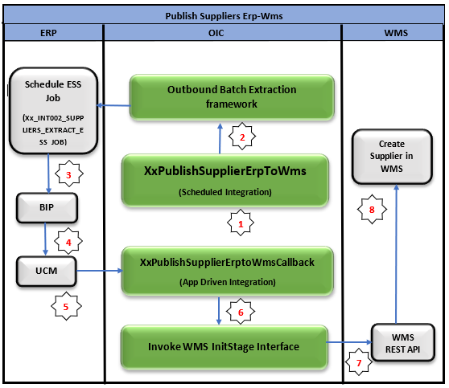

Pre-Requisites
- Send Email Integration “XxCommonNotificationHandler” should be deployed in the OIC.
- Lookup “XXDominoCommonLookup” should be present with all the required details regarding success/error email notify flag, success and error notify ToEmail Address in OIC.
- Lookup “XxDominoConstantLookup” should be present with all the required details regarding success and error notify FromEmail Address in OIC.
- Lookup “XXDominoWmsCompanyLookup” should be present to transform Fusion BU with WMS Company Code.

Integration Analysis – XxPublishSupplierErpToWms
This Integration component is responsible to export Suppliers from Fusion ERP to WMS system.

Integration Components
Below are the required components for this integration.

Integration Name | Integration Pattern | Package Name | Lookup Name
XxPublishSupplierErpToWms | Scheduled Orchestration |  | XXDominoCommonLookup,  XxDominoConstantLookup,  XXDominoWmsCompanyLookup
XxPublishSupplierErpToWmsCallback | App Driven Orchestration |  | XXDominoCommonLookup,  XxDominoConstantLookup,  XXDominoWmsCompanyLookup

Required Connections
Connection Name | Connection Type | Connection Role
XxDominoErpCloudConnection_WMSINT | Oracle ERP Cloud | Trigger and invoke
XxDominoWMSConnection | Oracle WMS Cloud | Trigger and invoke
XxAtpDb | Oracle ATP | Trigger and invoke

Integration Outline
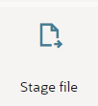
Trigger the ESS Job to Extract Supplier Data
Unzip the Output zip file and list down the .csv file i.e., report output file in OIC ICs stage
OIC Schedule
Integration
XxPublishSupplierErpToWms
Data origin of Bulk data, extract the Supplier records which are created and updated after last successful run of integration

UCM

Place the Output zip files of ESS job into Fusion UCM directory and get the document ID of file
OIC Callback
Integration
XxPublish Supplier
ErpToWms
Callback
Subscribes to the call back event of submitted ESS Job
Read the .csv report output file and write it into WMS API request format (XML Format) in OIC ICs stage
Invoke the WMS Init stage API Endpoint to load the data into WMS cloud
Corresponding status of file records (Success/Error) will be sent back by WMS API to OIC

Figure: Architecture Diagram

The Following section explains the step – by- step process to publish Suppliers from Fusion to WMS:

- Integration – XxPublishSupplierErpToWms
- Schedule Parameters: The integration has two schedule parameters which are as below, the integration will be triggered with those values assigned to these parameters.
Parameter name | Data type | Value
FromLastUpdateDate | Date | The value of “Start_time” from last successful run of the integration will be assigned to this parameter.
CompanyCode | String | Value for this parameter will be assigned through CompanyCode, which is maintained in OIC lookup.  Note: CompanyCode details provided below in AssignLocalVariables section.

- AssignGlobalVar: The Global variable will be the Integration code which will be fetched from lookup “XXDominoCommonLookup” maintained in OIC. With reference to this lookup, all other local variables will be fetched which are as below:
Variable name | Data type | Value
IntegrationCode | String | dvm:lookupValue('XXDominoCommonLookup','IntegrationCode', 'XXPUBLISHSUPPLIERERPTOWMS', 'IntegrationCode', '')  IntegrationCode will be fetched from OIC lookup “XXDominoCommonLookup”, with reference to this lookup all other local variables will be fetched.  Value for IntegrationCode variable is Integration identifier.

- AssignLocalVariables:
Variable name | Data type | Value
JobName | String | dvm:lookupValue('XXDominoCommonLookup', 'IntegrationCode', $IntegrationCode, 'Job_Name', '')  “Xx_INT002_SUPPLIERS_EXTRACT_ESS_JOB” - This value will be fetched from OIC common lookup based on the value of Integrationcode from AssignGlobalVar.
CompanyCode | String | dvm:lookupValue('XXDominoWmsCompanyLookup','Fusion_Bu_Name', $CompanyCode, 'WMS_Company_Code', '')  Value of variable will be fetched from OIC Lookup “XXDominoWmsCompanyLookup” based on Fusion BU WMS Company Code and Org mapping.

- CheckIntegrationDetails: This step will invoke the Oracle ATP DB connection to store the integration run details into custom table – “XXDOM_INT_LAST_RUN_DATE_T” which is a common table to store all the integration run details.
For the 1st ever run of integration the records will be inserted into ATP table and from next run onwards it will check if the record with the integration name is present and will update the record with required information as mentioned below.
  - Insert operation:
The below details will be inserted into stage table for 1st ever run of the integrations.
Table Name – “XXDOM_INT_LAST_RUN_DATE_T”
Table Column | Value
RECORD_ID | batch_record_id_seq.nextval
INTEGRATION_NAME | $IntegrationCode
PARENT_INSTANCE_ID | $self/nsmpr1:metadata/nsmpr1:runtime/nsmpr1:instanceId
CALLBACK_INSTANCE_ID | NULL
INT_RUNNING_FLAG | Y
BATCH_COMPLETION_FLAG | Y
LAST_RUN_DATE | sysdate
CREATED_BY | $self/nsmpr1:metadata/nsmpr1:runtime/nsmpr1:invokedBy
CREATION_DATE | sysdate
LAST_UPDATED_DATE | sysdate
LAST_UPDATED_BY | $self/nsmpr1:metadata/nsmpr1:runtime/nsmpr1:invokedBy
  - Update Operation:
The below details will get updated for Update operation for further runs of integration.
Table Name – “XXDOM_INT_LAST_RUN_DATE_T”
Table Column | Value
PARENT_INSTANCE_ID | $self/nsmpr1:metadata/nsmpr1:runtime/nsmpr1:instanceId
INT_RUNNING_FLAG | Y
BATCH_COMPLETION_FLAG | N
LAST_UPDATED_DATE | sysdate
LAST_UPDATED_BY | $self/nsmpr1:metadata/nsmpr1:runtime/nsmpr1:invokedBy

- ExportSuppliersReportData:
This step will fetch Supplier records from fusion which are created and updated based on the last execution run date by submitting the ESS job. The value of LAST_RUN_DATE from table XXDOM_INT_LAST_RUN_DATE_T will be assigned to ESS job parameter to fetch the records.
The value of Last Run date will get updated in stage table as mentioned above. After every successful completion of entire process and in next run the updated value will be passed to ESS job parameter. In case process completes in error, the value of LAST_RUN_DATE will not be updated, and same current value will be passed for next run of the integration.
In case of Ad-Hoc run, the value of “FromLastUpdateDate” variable mentioned in schedule parameter tab (in Step 1) will be passed by user and once process is completed the value of “FromLastUpdateDate” will be updated to “NULL”.

- Integration – XxPublishSupplierErpToWmsCallback

- ERPCallBack: This is oracle ERP cloud adapter connection which will subscribe to the ESS job event submitted by the above integration Point A.
- Trigger Purpose: Receive Business Events raised within ERP Cloud.
- Business Event for Subscription: ERP Integration Outbound Event.
- Event Description - This event notifies that export bulk data is completed via ERP Integration web service.
- AssignGlobalVar: The Global variable will be the Integration code which will be fetched from lookup – “XXDominoCommonLookup” maintained in OIC. With reference to this lookup, all other local variables will be fetched which are as below-
Variable name | Data type | Value
IntegrationCode | String | dvm:lookupValue('XXDominoCommonLookup', 'IntegrationCode', 'XXPUBLISHSUPPLIERERPTOWMS', 'IntegrationCode', '')  IntegrationCode will be fetched from OIC lookup “XXDominoCommonLookup”, with reference to this lookup all other local variables will be fetched.

- AssignLocalVariables:
Variable name | Data type | Value
IntegrationID | String | dvm:lookupValue('XXDominoCommonLookup', 'IntegrationCode', $IntegrationCode, 'RiceID', '')  “INT002” – This value will be fetched from OIC common lookup based on the value of Integration code from AssignGlobalVar Source value.
OICTempFileLocation | String | dvm:lookupValue('XXDominoCommonLookup', 'IntegrationCode', $IntegrationCode, 'TempFileLocation', '')  Default Value – “/Integration/Suppliers/Reports” - This will be the temporarily path to locate the path while reading, listing the .csv files from UCM upload through ESS job.
ErrNotifyEmail | String | dvm:lookupValue('XXDominoCommonLookup','IntegrationCode', $IntegrationCode, 'FailureNotify', '')  This value will be fetched from OIC common lookup – XXDominoCommonLookup to send failure notification in case integration fails due to any error.
SuccessNotifyEmail | String | dvm:lookupValue('XXDominoCommonLookup','IntegrationCode', $IntegrationCode, 'SuccessNotify', '')  This value will be fetched from common lookup – XXDominoCommonLookup to send Success notification after normal process completion.
EmailFrom | String | dvm:lookupValue('XxDominoConstantLookup', 'ID', 'FromEmailId', 'Value', '')  This value will be fetched from OIC lookup – XxDominoConstantLookup which is used to send notification email from OIC service.

- UpdateInstanceId: This step will invoke the oracle ATP DB to update the common stage parent table – “XXDOM_INT_LAST_RUN_DATE_T” with callback instance Id details. The callback instance id will get updated in every run of the callback integration to store the latest information. The parameter “CALLBACK_INSTANCE_ID” will be created in Update SQL and the value of this will be passed to table column mentioned below for update.
Table Column | Value
CALLBACK_INSTANCE_ID | $self/nsmpr0:metadata/nsmpr0:runtime/nsmpr0:instanceId

- Switch: This object will work as IF/else which will route the integration operation path based on the conditions assigned to it.
  - EssJobStatus: This will validate the status of the ESS job if summary status of the ESS is “SUCCEEDED” then integration will route through this path and perform next operations.
  - Otherwise: If the ESS job completed in any other status than above then it will route through this and will call the end of the integration.
- ScopeSupplierRequestErpToWms:
- getDocumentforDocumentId: This is ERP cloud adapter connection which will fetch documentId of the files submitted through ESS job. This value will be mapped from documentID of ERPCallBack trigger.
- WriteContentAsZIP: Once the document ID is fetched, this step will create single zip file for all the output files received in ICS stage using opaque schema.
- UnzipUcmFiles: The zip created in WriteContentAsZIP step will be unzipped at temporary location, the value for this will be assigned from local variable “p_OIC_Temp_File_Location” (refer the above AssignLocalVariables section).
- ListUnzipFiles: This step will filter out the .csv file from the unzipped file which will be Supplier report output file.
- Switch:
  - CheckCsvFile: This route will check the count of the .csv files from listed files in ICS stage in previous step. If the count is greater than zero, then integration will be routed through this path for next steps.
  - Otherwise: If there are no csv files listed (Count is zero), then integration will be routed through this path and will stop processing further.
- ReadFiles: This operation will read the .csv file in ICS stage in segments with reference to .csv BIP report file of segment size of 200 records in each iteration.
- WriteBIP: Write the Read Response of BIP into required XML structure through WMS xsd schema file to send the request payload to WMS API. The mapping will be as per the mapping document provided in Sample Data & Mapping Template section in this document.
- InvokeInitStageInterfaceSupplier: This step will call the WMS common API - “/wms/api/init_stage_interface/” which is responsible to post the data to WMS system. In case of any error while calling this API, notification will be sent through common notification error handler integration to respective team.
Three query parameters are added to this API to send the request as below -
  - Query Parameters-
    - Async - This will be set to value as “False”.
    - Validate_xml - This will be to set to value as “True”.
    - Xml_data - This will be mapped with the response of write file which sends the data in parameter to WMS API to post the data to WMS side. The data will be in decodeBase64 reference value of Write response.
The request will be sent to WMS API as – Send query parameters as form data in message body.
Once the data is successfully loaded into WMS side, WMS API will send consolidated response for all records in file back to OIC, in case of any error while posting the data to WMS same will be captured by WMS API and send back to OIC.
WMS Request and Response Schemas:
WMS Request | lgf_vendor-22D.xsd
WMS Response | WMS_Response.xsd

Sample WMS Response:
WMS Response | Response Message
SUCCESS | <executeResponse xmlns="http://xmlns.oracle.com/cloud/adapter/REST/InvokeInitStageInterfaceSupplier_REQUEST/types">  <root xmlns="http://xmlns.oracle.com/cloud/adapter/nxsd/surrogate/response/InvokeInitStageInterfaceSupplier/">  <success>True</success>  <response>  <message>Stage table processing complete</message>  </response>  </root>  <HTTPHeaders />  </executeResponse>
ERROR | Error while initializing stage interface.  <![CDATA[<?xml version="1.0" encoding="utf-8"?>  <root><success>False</success><response>  <message>Data Validation Error</message>  <errors><error><key>Required field</key>  <msg>Exception in process_stgdtl: Dtl Error:  Invalid Supplier: -----  [Code: EPT2007~^~] </msg></error></errors></response></root>.A 400 Bad Request Error indicates that the target service is unable (or refuses) to process the request sent by the client (Oracle Integration Cloud), due to an issue that is perceived by the server to be a client problem. You can trace the cURL representation of the request sent to the target service from the Oracle Integration Cloud server logs.  Try invoking the target service using cURL. It may also be that one of the intermediaries (proxy, LBR) could be returning this code. ]]>
In case of WMS API invocation error, it is mostly due to data issue sent from fusion. In this case, WMS API will reject the entire file and sent back the response thereafter the data needs to correct in fusion and resend the data in next run of integration.
- InvokeSuccessHandlerNotification: Once the data is posted into WMS side with success response and all the operations in Integration are completed normal then success email notification will be sent to respective team through “XxCommonNotificationHandler”.
With map activity, process will map the below values to common error handler Integration.
Request Parameters | Values
IntegrationCode | $IntegrationCode
IntegrationID | $IntegationID
InstanceID | $self/nsmpr1:metadata/nsmpr1:runtime/nsmpr1:instanceId
ErrorCode | NULL
ErrMsg | NULL
EmailFrom | $EmailFrom
SuccessNotifyEmail | $SuccessNotifyEmail
EmailSub | concat("FYI",":","SUCCESS",":",$self/nsmpr7:metadata/nsmpr7:integration/nsmpr7:name,"(",$self/nsmpr7:metadata/nsmpr7:integration/nsmpr7:version,")",":",$self/nsmpr7:metadata/nsmpr7:runtime/nsmpr7:instanceId )
Logging | Y

- ScopeSupplierRequestErpToWms Fault Handler:
  - In fault handler section, process will call “XxCommonNotificationHandler” local integration which is to capture the error occurred in APIs invocation process. If any service exception occurred in ERP cloud adapter or any error in invoking WMS rest API, it will be handled in scope fault handler and email notification will be sent to concern team.
  - With map activity, process will map the below values to common error handler Integration.
Request Parameters | Values
IntegrationCode | $IntegrationCode
IntegrationID | $IntegationID
ErrorCode | $CurrentFaultObject/nsmpr0:APIInvocationError/nsmpr0:errorCode.
ErrMsg | $CurrentFaultObject/nsmpr0:APIInvocationError/nsmpr0:detail
EmailFrom | $EmailFrom
ErrNotifyEmail | $ErrNotifyEmail
EmailSub | concat(FYI",":","ERROR",":",$self/nsmpr1:metadata/nsmpr1:integration/nsmpr1:name,"(",$self/nsmpr1:metadata/nsmpr1:integration/nsmpr1:version,")",":",$self/nsmpr1:metadata/nsmpr1:runtime/nsmpr1:instanceId )
Logging | Y
  - Local integration “XxCommonNotificationHandler” will be triggered based on above mentioned values in MAP activity and will send notification email to concern team.

Main Code Flow Snippet
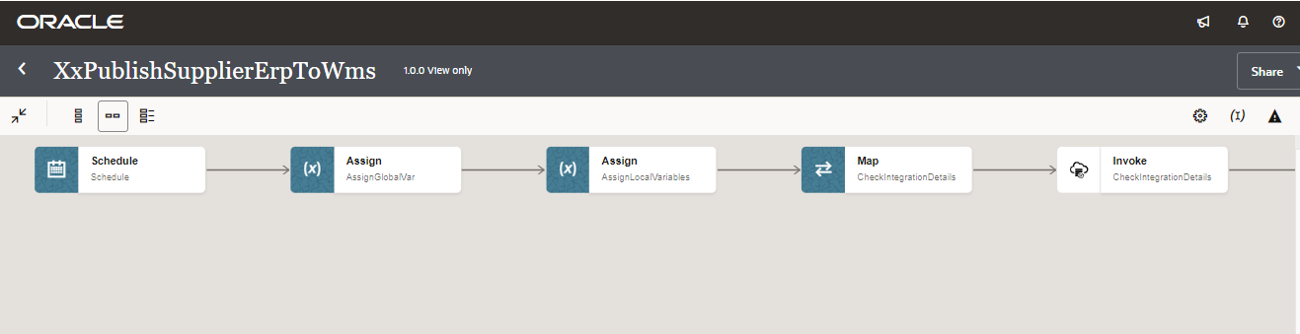
4
3
2
1

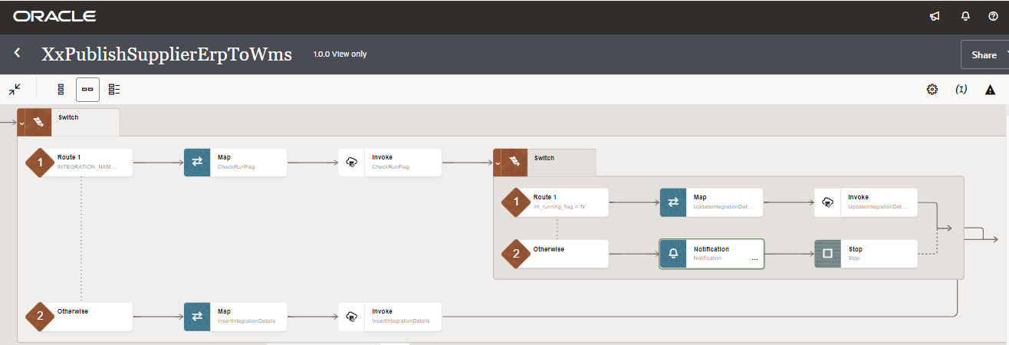
4b
4a

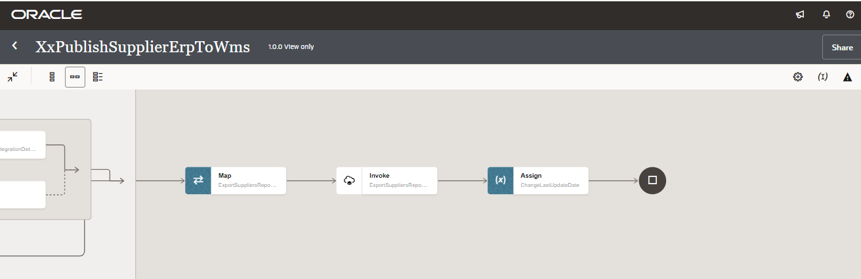
5

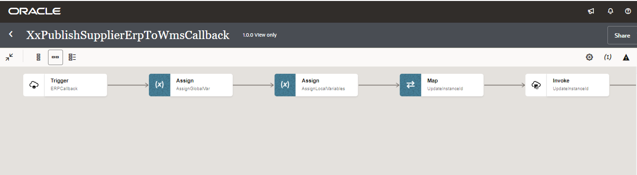
9
8
7
6

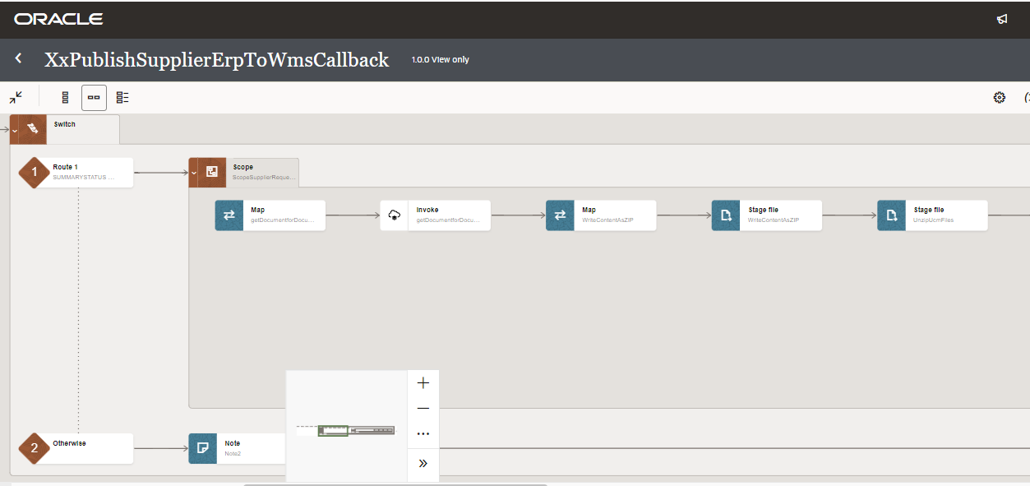
11c
11b
11a
11
10b
10a

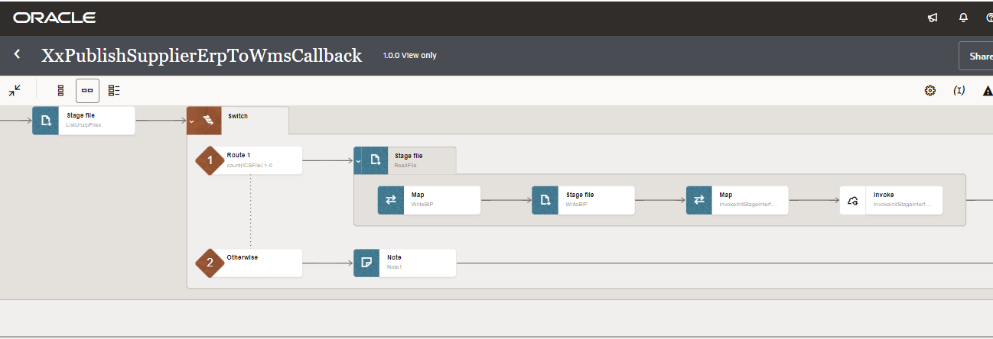
11h
11g
11f
11e-b
11e-a
11ea
11d

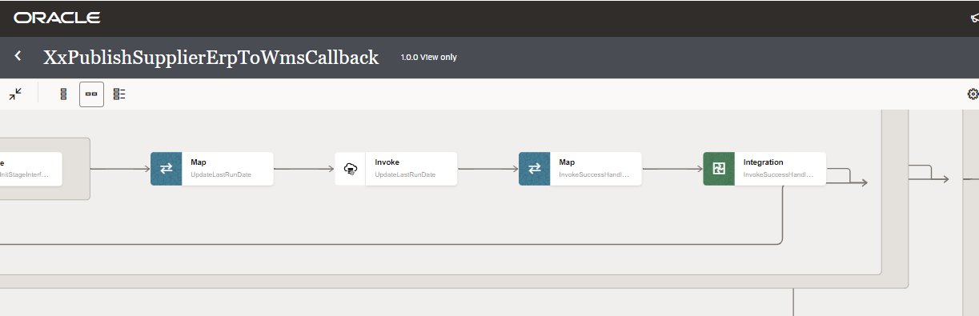

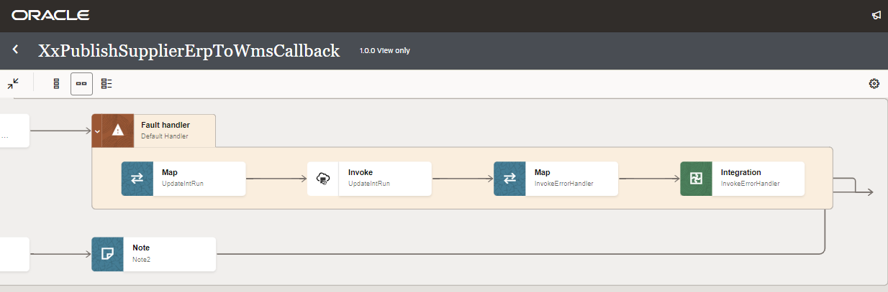Figure: Main flow code snippet
12a
12b

Global Fault
- The global fault handler is responsible for the whole execution scope and processes the exceptions occurred in the individual stages.
- AssignGlobalVariable: The Global variable will be the Integration code which will be fetched from lookup “XXDominoCommonLookup” maintained in OIC. With reference of this lookup, all error variable values will fetch which are given as below:
Variable name | Data type | Value
IntegrationCode | String | dvm:lookupValue('XXDominoCommonLookup','IntegrationCode', 'XXPUBLISHSUPPLIERERPTOWMS', 'IntegrationCode', '')  IntegrationCode will be fetched from OIC lookup “XXDominoCommonLookup”, with reference to this lookup all other local variables will be fetched.  Value for IntegrationCode variable is Integration identifier.

- AssignErrorVariable:
  - Using assign activity, variables will be declared to map the values required for invoking common error handler integration.
Variable | Values
IntegrationID | dvm:lookupValue('XXDominoCommonLookup','IntegrationCode', $IntegrationCode, 'RiceID', '')  This value will fetched from OIC lookup- XXDominoCommonLookup with reference of integration code value from Global variable.
ErrNotifyEmail | dvm:lookupValue('XXDominoCommonLookup','IntegrationCode', $IntegrationCode, 'FailureNotify', '')  This value will be fetched from OIC lookup XXDominoCommonLookup with reference of integration code value from Global variable. It will be failure notify email id.
EmailFrom | dvm:lookupValue('XxDominoConstantLookup', 'ID', 'FromEmailId', 'Value', '')  This value will be fetched from OIC constant lookup - XxDominoConstantLookup

- InvokeCommonErrorHandler:
  - The global fault handler will invoke the local integration “XxCommonNotificationHandler” which captures the error occurred at any step in overall integration flow and notify over email.
  - Using the map activity “Map to InvokeCommonErrorHandler”, process would map the below values required for XxCommonNotificationHandler.
Request Parameters | Values
IntegrationCode | $IntegrationCode
IntegrationID | $IntegationID
ErrorCode | $CurrentFaultObject/nsmpr0:APIInvocationError/nsmpr0:errorCode.
ErrMsg | $CurrentFaultObject/nsmpr0:APIInvocationError/nsmpr0:detail
EmailFrom | $EmailFrom
ErrNotifyEmail | $ErrNotifyEmail
EmailSub | concat($InstanceName,":","FYI",":","ERROR",":",$self/nsmpr1:metadata/nsmpr1:integration/nsmpr1:name,"(",$self/nsmpr1:metadata/nsmpr1:integration/nsmpr1:version,")",":",$self/nsmpr1:metadata/nsmpr1:runtime/nsmpr1:instanceId )
Logging | Y

In addition to this, if there is a requirement to extract the data on demand and interface it to WMS then Adhoc Schedule can be used.
ESS Job name – “Xx_INT002_SUPPLIERS_EXTRACT_ESS_JOB”

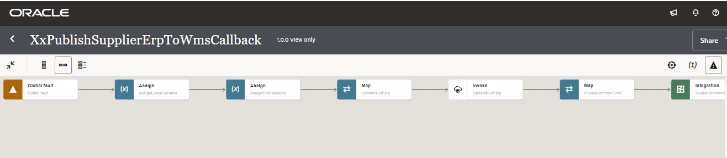Figure 3 : Global Fault Code Snippet
4
3
2
1

Migration Steps
2
4

- Import “XXPUBLISHSUPPLIERERPTOWMS_01.00.0000.iar” in OIC environment.
- Import "XXPUBLISHSUPPLIERERPTOWMSCALLBAC_01.00.0000.iar" in OIC environment.
- Update the OIC Connections with Password, details as per the Environment.
- Validate the "XxCommonNotificationHandler", which is deployed in OIC. Update the values of Instance URL, Instance Name in Domino Constant lookup.
- Configure the Connection with Dev Instance URL, Instance Name (whenever updated) which is present in Domino Lookup maintained in OIC.
- Complete the OIC integration configuration and activate OIC service.

Unit Testing
2
3

Please refer the attached file for the Unit Test cases performed for this integration.

Open and Closed Issues

This section is used to summarise any open and closed questions relating to Error Handler.

ID | Topic | Description | Status | Owner
1
2.


Copyright © 2015, Oracle and/or its affiliates. All rights reserved. This document is provided for information purposes only and the contents hereof are subject to change without notice. This document is not warranted to be error-free, nor subject to any other warranties or conditions, whether expressed orally or implied in law, including implied warranties and conditions of merchantability or fitness for a particular purpose. We specifically disclaim any liability with respect to this document and no contractual obligations are formed either directly or indirectly by this document. This document may not be reproduced or transmitted in any form or by any means, electronic or mechanical, for any purpose, without our prior written permission.
Oracle and Java are registered trademarks of Oracle and/or its affiliates. Other names may be trademarks of their respective owners.
AMD, Opteron, the AMD logo, and the AMD Opteron logo are trademarks or registered trademarks of Advanced Micro Devices. Intel and Intel Xeon are trademarks or registered trademarks of Intel Corporation. All SPARC trademarks are used under license and are trademarks or registered trademarks of SPARC International, Inc. UNIX is a registered trademark licensed through X/Open Company, Ltd. 1212

Connect with us
blogs.oracle.com
facebook.com/oracle
twitter.com/oracle
oracle.com

